# CHARTING THE COURSE OF INNOVATION:A STARTUP ANALYSIS

# PROJECT REPORT

# SYNOPSIS:

1. INTRODUCTION

1.1 Overview

1.2 Purpose

2. PROBLEM DEFINITION AND DESIGN THINKING

2.1 Empathy map

2.2 Ideation and Brainstorming map

3. RESULT

4. ADVANTAGES AND DISADVANTAGES

5. APPLICATIONS

6. CONCLUSION

7. FUTURE SCOPE

8. APPENDIX (Source Code)

1. INTRODUCTION

1.1 OVERVIEW

A startup is a company in the early stages of development that is set up by one or several people to enter an existing market with unique products or services. Startup companies often face insufficient capital to fund their business operations to be at the same level as already established companies. As a result, the prime source of funding comes from the founders’ friends and families.

In their newness, startups usually focus on raising capital to further product development. Raising such funds is always a long and tedious process, and a startup needs to make a strong argument that supports the viability of its business idea. Some renowned startup companies include Airbnb, SpaceX, Avant, and Pinterest.

* 1. PURPOSE

The purpose of charting the course of innovation through startup analysis is to assess the potential of a startup to create and deliver innovative products or services in the market. By analyzing startups, investors, entrepreneurs, and other stakeholders can gain insights into the startup's ability to succeed and create value.

Through startup analysis, one can evaluate the founding team, the product or service, the market opportunity, and the financial performance of the startup. These evaluations can help identify potential risks and challenges that the startup may face and provide a roadmap for addressing them.

By understanding the potential for innovation of a startup, investors can make informed investment decisions and entrepreneurs can refine their business strategies. Additionally, startup analysis can help identify trends and opportunities in specific industries or sectors, leading to new innovations and growth.

Overall, the purpose of charting the course of innovation through startup analysis is to identify and support startups that have the potential to create significant value and change the way we live and work.

2. PROBLEM DEFINITION AND DESIGN THINKING

2.1 EMPATHY MAP

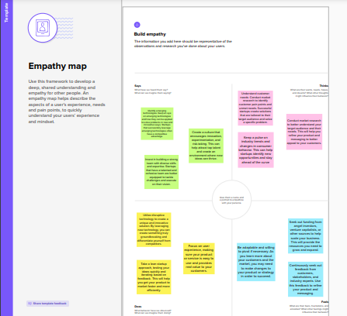

2.2 IDEATION AND BRAINSTORMING MAP

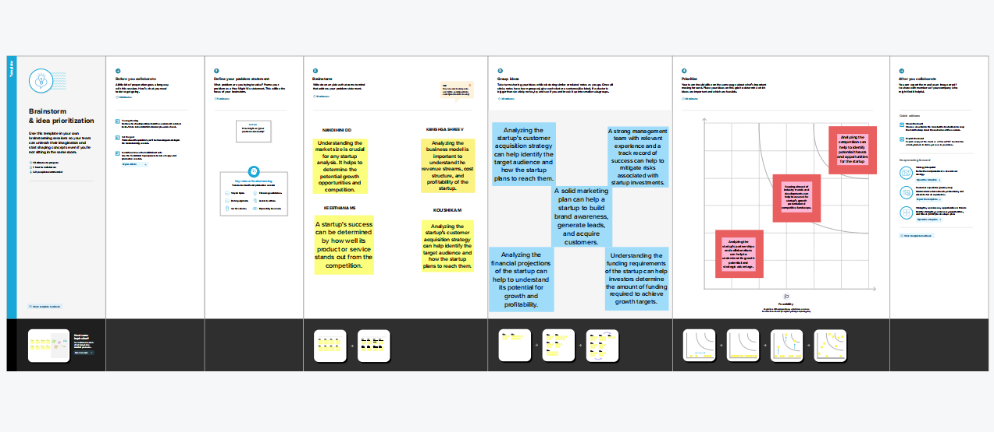

3.RESULT

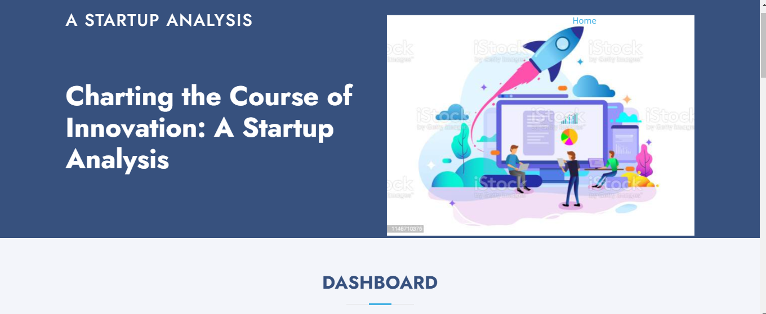

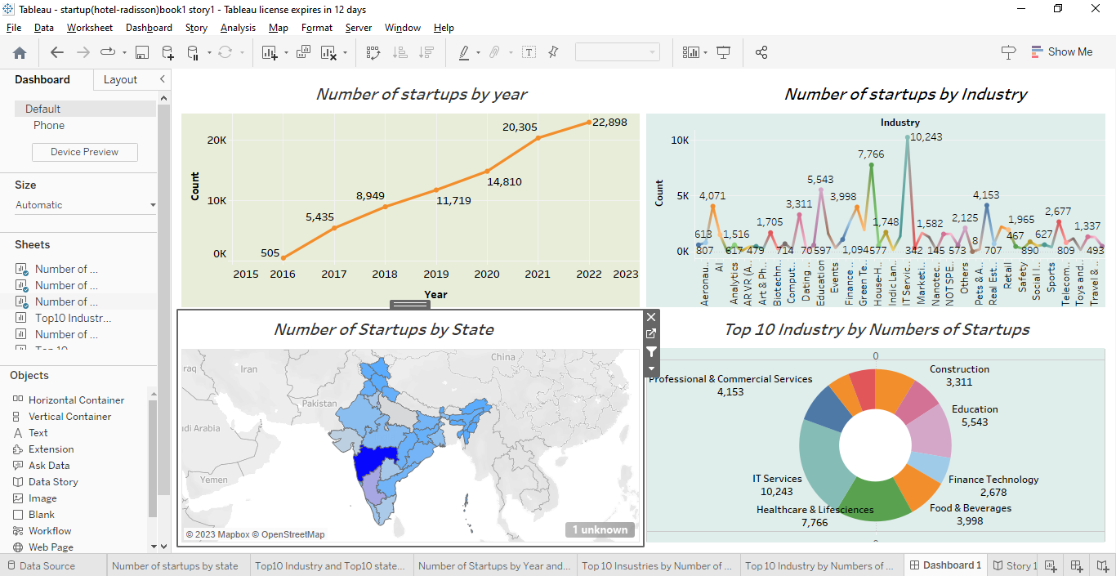

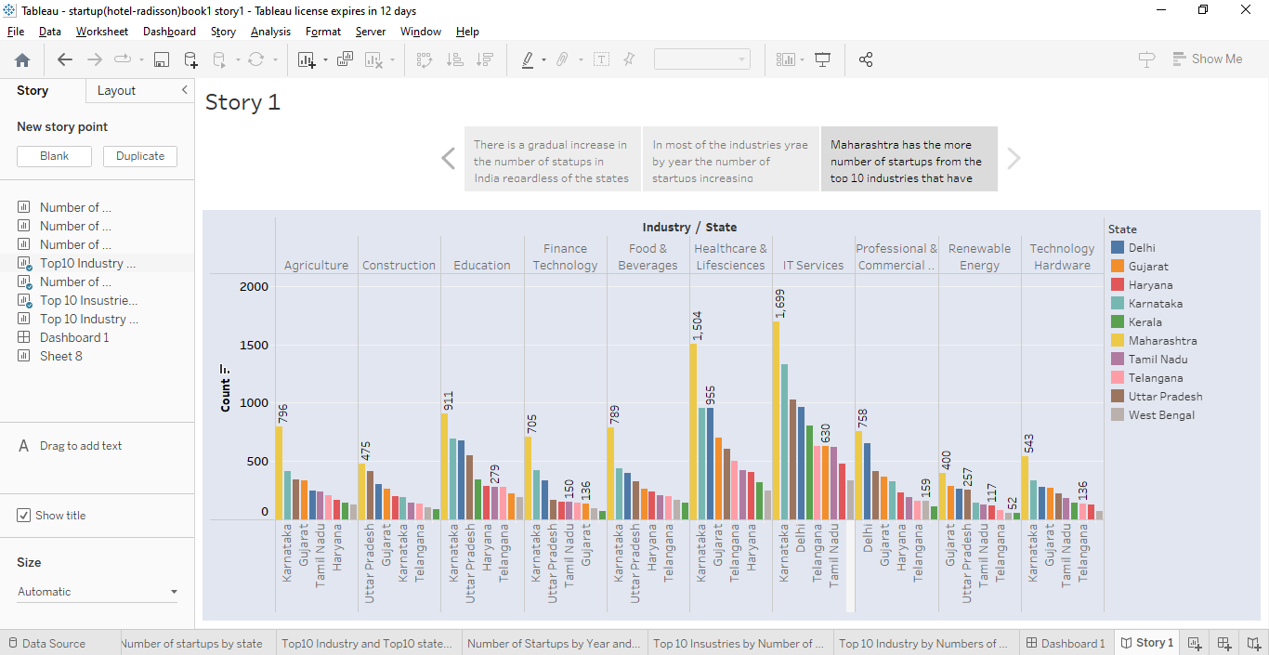

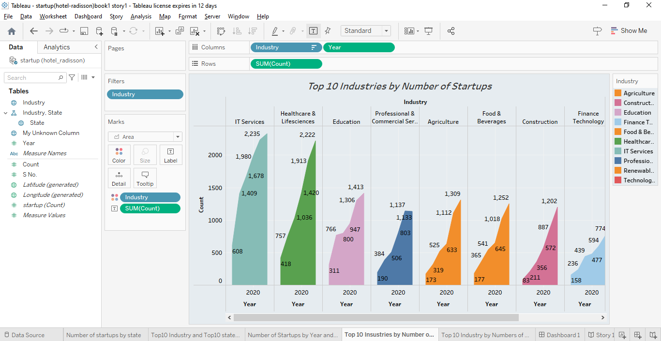

4.ADVANTAGES AND DISADVANTAGES

ADVANTAGES:

1. Helps startups identify and address potential roadblocks early on in the process.
2. Provides insights into the industry and competition.
3. Helps startups stay on track and prioritize goals.
4. Enables startups to create a more effective business plan.
5. Can help secure funding by showing investors a clear path to success.
6. Enables startups to adapt to changing market conditions and consumer needs.
7. Helps identify areas where the startup can innovate and differentiate itself from competitors.
8. Provides a framework for measuring progress and success.
9. Helps startups create a culture of innovation and experimentation.
10. Provides a foundation for long-term growth and sustainability.

DISADVANTAGES :

1. Can be time-consuming and costly to conduct a comprehensive analysis.

2. May not accurately predict market trends or consumer behavior.

3. Can lead to analysis paralysis, where startups become too focused on planning and analysis and fail to take action.

4. Analysis may be based on incomplete or inaccurate information.

5. May not be relevant to startups operating in highly disruptive or emerging industries.

6. Can be difficult to accurately quantify the return on investment of the analysis.

7. May lead to tunnel vision, where startups become too focused on their initial strategy and fail to adapt to changing conditions.

8. Can lead to a loss of creativity and spontaneity.

9. May create unrealistic expectations for investors or stakeholders.

10. Can be difficult to balance the need for analysis with the need for quick decision-making in a fast-paced startup environment.

1. APPLICATION:

Identifying emerging trends and opportunities: By analyzing the strategies and outcomes of successful startups, entrepreneurs can identify emerging trends and opportunities in the market. This information can help them to generate new business ideas or pivot their existing business to better capitalize on these trends. Evaluating investment opportunities: Investors can use startup analysis to evaluate potential investment opportunities. By examining the startup's business plan, market potential, and past performance, investors can determine whether or not to invest in the startup. Assessing market competition: Startup analysis can help entrepreneurs to assess the competition in their market. By studying the strategies and outcomes of competing startups, entrepreneurs can identify areas where they can differentiate themselves and gain a competitive advantage .Improving product development: By analyzing user feedback and market demand, startups can refine their product development strategies to better meet the needs of their customers. This can lead to the development of more successful products and services. Enhancing strategic planning: Startup analysis can provide valuable insights into the strategic planning process. By studying the successes and failures of other startups, entrepreneurs can identify potential roadblocks and develop more effective strategies for achieving their goals. Building strategic partnerships: By analyzing the strategies and outcomes of other startups, entrepreneurs can identify potential partners with complementary strengths and resources. This can lead to the development of strategic partnerships that can help startups scale and grow more quickly. Informing regulatory compliance: Startups often face complex regulatory requirements, and startup analysis can help entrepreneurs stay up-to-date on relevant regulations and ensure compliance. This can reduce the risk of legal and financial consequences for non-compliance. Enhancing customer engagement: By analyzing customer feedback and behavior, startups can improve their customer engagement strategies and build stronger customer relationships. This can lead to increased customer loyalty, higher retention rates, and increased revenue.

1. CONCLUSION:

Charting the course of innovation in startups is a crucial process for entrepreneurs, investors, and other stakeholders who are looking to understand the dynamic and ever-changing entrepreneurial landscape. By carefully analyzing the strategies and outcomes of successful startups, we can identify emerging trends and opportunities, evaluate potential investment opportunities, assess market competition, and inform strategic planning and decision-making. The process of charting the course of innovation involves several key stages, including idea generation, funding, research and development, launch, scaling, and adaptation. Throughout these stages, startups must demonstrate creativity, strategic thinking, and perseverance to succeed. There are numerous applications of startup analysis, including improving product development, enhancing team performance, building strategic partnerships, and mitigating risk. By leveraging startup analysis, entrepreneurs and investors can gain valuable insights into the factors that contribute to startup success and develop more effective strategies for achieving their goals.

1. FUTURE SCOPE

The future of charting the course of innovation in startups looks promising, as the entrepreneurial landscape continues to evolve and new opportunities emerge. Greater use of data analytics: As the amount of data available to startups continues to grow, we may see a greater emphasis on data analytics in startup analysis. This could include the use of artificial intelligence and machine learning to identify patterns and trends in startup performance data. More emphasis on social impact: With increasing demand for social responsibility and sustainability, we may see more startups focusing on social impact as a key driver of success. This could lead to new metrics for evaluating startup performance and new approaches to startup analysis that prioritize social impact. Increased focus on emerging markets: As the global economy continues to shift and evolve, we may see more startups targeting emerging markets and using startup analysis to inform their strategies in these regions. Integration of blockchain technology: The use of blockchain technology could enable startups to more securely and transparently track and analyze their performance data, leading to more accurate and reliable startup analysis. More collaborative approaches: The future of startup analysis may involve more collaborative approaches, where entrepreneurs, investors, and other stakeholders work together to share data, insights, and best practices.

1. APPENDIX (Source code)

